State of Nebraska Driver’s Motor Vehicle Accident Report Questions? 1-402-479-4645
Every operator of a motor vehicle involved in an accident resulting in either injury, death, or damages over $1,000.00 to the property of any one person (including the operator) must complete and return this confidential report within 10 days following the accident.  If the driver is physically unable to fill out the report, the owner of the motor vehicle is required to do so. If you have difficulty filling out the report, consult your insurance agent or nearest police authority. Failure to report an accident as required is a misdemeanor, punishable by a fine of $50.00.  Report Form Instructions (print in ink or type)  Accident location:  After entering the date, county, and city information, describe where the accident occurred. If the crash happened on a numbered rural highway, give the direction and number of feet from the nearest milepost. If your accident occurred on an urban highway, skip the “distance from milepost” section.  If the accident occurred at an intersection, enter the name of the intersecting roadway. For those accidents not located at an intersection, enter the approximate distance in feet from the nearest landmark (intersection, city limit, bridge name, etc.).  Vehicle and driver involvement:  Answer the questions asked about your vehicle and any other vehicle involved in the accident to the best of your ability. If more than two vehicles were involved, complete an accident form(s). Refer to your vehicle as vehicle number 1 throughout the report. Information on bicycles may be entered in the “other vehicle” section.  Be careful when listing the estimated damage to your vehicle. Use a garage estimate whenever possible. | 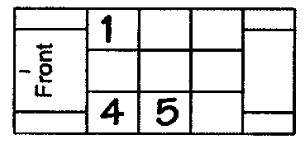  Airbag deployment coding:  Front row  Second row  Third row  For every occupant in your vehicle, including yourself, enter the correct airbag deployed code according to each person’s seating position. For help in marking the car graph, see the following example:  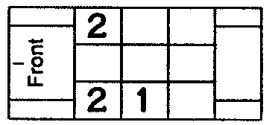  Example: There are a total of three occupants in the vehicle, with the driver and one occupant in front, and the third person in the back seat behind the driver. Both the driver and the front passenger seats are equipped with front air bags. The driver’s air bag does not deploy during the crash, the front seat passenger’s air bag does deploy. The passenger in the backseat does not have an airbag available. The car graph would be marked as shown.  Front row  Second row  Third row  Restraint use coding:  For every occupant in your vehicle, including yourself, enter the correct restraint code according to each person’s seating position. For help in marking the car graph, see the following example.  Example: If there were three occupants in the vehicle, with the driver and one occupant in front, both using lap and shoulder belts, and the third occupant in the back seat behind the driver not using any restraint, the car graph would be marked as shown.  Costume helmet – Non-DOT approved helmet. |  |  | 1 Deployed – front  2 Deployed – side  3 Deployed – both front/side  4 Not deployed  5 Not applicable/  No airbag available  6 Unknown  1 None used – vehicle occupant  2 Lap & shoulder belt used  3 Shoulder belt only used  4 Lap belt only used  5 Child safety seat used  6 Child booster seat used  7 DOT approved helmet used  8 Costume helmet used  9 Restraint use unknown
How to enter information about injured persons:  Carefully complete this section for each person injured in your vehicle and any pedestrians or bicyclists injured in the accident. After providing the name, address, date of birth, and sex of each injured person, answer questions 1-5 by writing your response in the appropriate box. If you need to provide injury information for more than four persons, complete another report form. | Example: Assume the car you were driving collided with a bicycle. The bicycle operator was seriously injured and rushed to the hospital. Although you bruised your shoulder and one of your passengers complained of neck pain, no one riding in your vehicle received immediate medical treatment.
 |  | DATE OF BIRTH  (MM / DD / YYYY) | 1 |  | 2 | 3 | 4 | 5 | SEX  M F
 |  | DATE OF BIRTH  (MM / DD / YYYY) | Seat  Position |  | Eject | Body Region | Injury  Sev. | Trans. | SEX  M F
NAME ADDRESS  Sam Public 123 Elm St. Lincoln, NE 68502 |  | 10 / 17 / 1993 | 19 |  |  | 05 | 2 | 2 | M
NAME ADDRESS  Jan Doe 3456 Vermont Ave. Lincoln, NE 68503 |  | 07 / 31 / 1964 | 01 |  | 1 | 06 | 3 | 1 | F
NAME ADDRESS  Mary Doe 3456 Vermont Ave. Lincoln, NE 68503 |  | 12 / 30 / 1989 | 03 |  | 1 | 03 | 4 | 1 | F
NAME ADDRESS |  | / /

Instruction Page for Page 1 of the Accident Report.
Discard this sheet after use.
How to Complete the Back Side of the Accident Report
Answer all of the questions asked about the crash by checking the proper box.
Draw a diagram to show what happened. Provide an explanation of the events which occurred. Instructions on what to show on the diagram are provided below.
If property was damaged, briefly describe it. Enter the owner’s name and address and estimate the cost of the damage.
Check whether or not an investigator was contacted. If so, give the officer’s name or badge number and the name of their agency.
Do not forget to sign the accident report before mailing it to:
Highway Safety – Accident Records Bureau
Nebraska Department of Roads
P.O. Box 94669
Lincoln, NE 68509-4669
What to show on the diagram  1. In the upper left corner, draw an arrow to indicate north.  2. Name all streets and roads.  3. Number each vehicle and use a solid arrow to show the paths the vehicles or pedestrians were traveling before the collision.  4. Draw the vehicle positions at the point of collision.  5. Use a dotted arrow to indicate the post-crash paths of the vehicles, and draw the vehicles where they came to rest.  6. Identify any objects involved (bridges, buildings, guardrail, animals, etc.). If the object was off the roadway, note the distance from the edge of the road.  7. Give distances to landmarks (intersections, mileposts, bridges, railroad crossings, etc.). | Example Diagram: Typical Rural Accident
 | 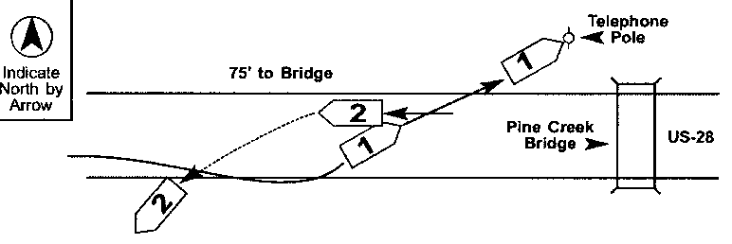
 | The right front wheel of No. 1 slipped off the edge of the pavement. While trying to get back on the pavement, the driver turned too sharply and allowed his car to cross the centerline where it struck the left rear side of No. 2. Both vehicles left the roadway after the collision and No. 1 then struck a telephone pole.
 | Example Diagram: Intersection-related Accident
 | 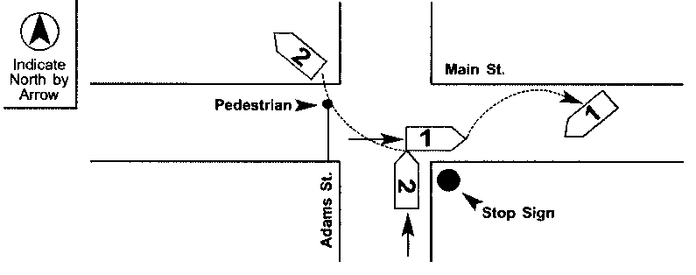
 | No. 2, going north on Adams Street, failed to stop before entering the intersection with Main Street. No. 1 was going east on Main Street. No. 2 struck the right side of No. 1 and No. 2 then went over the curb after striking a pedestrian, who was trying to cross Main Street.

Instruction Page for Page 2 of the Accident Report.
Discard this sheet after use.

Use Black State of Nebraska Driver’s Motor Vehicle Accident Report Questions? 1-402-479-4645

or Blue Ink Mail within 10 days of accident to: Highway Safety, Nebraska Department of Roads, P.O. Box 94669, Lincoln, NE 68509-4669
DATE OF  ACCIDENT |  |  |  |  |  |  | M |  |  |  | M |  |  | / | D | D |  | / |  |  |  | Y |  | Y |  |  |  | Y |  |  |  | Y |  |  |  |  |  |  | S |  |  |  | M |  |  |  |  | T |  |  |  |  | W |  | T |  |  | F |  |  | S |  |  |  |  | TIME OF ACCIDENT  (In Military Time) |  |  |  |  |  |  |  |  |  |  |  |  |  |  |  |  |  |  |  |  |  |  |  |  |  |  | STATE USE ONLY
 |  |  |  |  |  |  |  |  |  |  |  |  |  |  |  |  |  |  |  |  |  | 2 |  | 0
LOCATION OF ACCIDENT |  |  |  | COUNTY |  |  |  |  |  |  |  |  |  |  |  |  |  |  |  |  |  |  |  |  |  |  |  |  |  |  |  |  |  |  |  |  |  |  |  |  |  |  |  |  |  |  |  |  |  |  |  |  | CITY |  |  |  |  |  |  |  |  |  |  |  |  |  |  |  |  |  |  |  |  |  |  |  |  |  |  |  |  |  |  |  |  |  |  |  |  |  |  |  | Total Number of  Vehicles Involved
 |  |  |  | ROAD ON WHICH  ACCIDENT OCCURRED |  |  |  |  |  |  |  |  |  |  |  |  |  |  |  |  | STREET/HIGHWAY NO. (If no Hwy. No., identify by name) |  |  |  |  |  |  |  |  |  |  |  |  |  |  |  |  |  |  |  |  |  |  |  |  |  |  |  |  |  |  |  |  |  |  |  |  |  |  |  |  |  |  |  |  |  |  |  |  |  |  |  |  |  |  |  |  |  |  |  |  |  |  | Posted Speed Limit on the Street You Were Traveling
 |  |  |  | DISTANCE FROM  MILEPOST |  |  |  |  |  |  |  |  |  |  |  | FEET |  |  |  |  |  |  |  |  |  |  |  |  |  |  | N |  |  |  | S |  |  | E |  | W |  |  |  |  | OF MILEPOST NO. |  |  |  |  |  |  |  |  |  |  |  |  |  |  |  |  |  |  |  |  |  | HIGHWAY NO. |  |  |  |  |  |  |  |  |  |  |  |  |  |  |  | PRIVATE  PROPERTY? |  |  |  |  |  |  |  |  |  | Yes No |  |  |  |  |  |  | ONE-WAY STREET? |  |  |  |  |  |  |  | Yes No
 |  |  |  | IF AT INTERSECTION |  |  |  |  |  |  |  |  |  |  |  |  |  |  |  |  |  |  |  |  |  |  |  |  |  |  |  |  |  |  |  |  |  |  |  |  |  |  |  |  |  |  |  |  |  |  |  |  | IF NOT AT INTERSECTION
 |  |  |  | NAME OF INTERSECTING ROADWAY |  |  |  |  |  |  |  |  |  |  |  |  |  |  |  |  |  |  |  |  |  |  |  |  |  |  |  |  |  |  |  |  |  |  |  |  |  |  |  |  |  |  |  |  |  |  |  |  | FEET |  |  |  |  |  |  | MILES |  |  |  |  |  |  |  |  | N |  | S |  |  | E |  |  |  | W |  | OF NEAREST STREET, BRIDGE, RAILROAD CROSSING
 |  |  |  | IF ACCIDENT WAS OUTSIDE CITY LIMITS, INDICATE DISTANCE FROM NEAREST TOWN |  |  |  |  |  |  |  |  |  |  |  |  |  |  |  |  |  |  |  |  |  |  | MILES |  |  |  |  |  |  |  |  |  |  |  |  |  |  |  |  |  |  |  | N |  |  | S |  |  |  | E |  |  | W |  | AND MILES |  |  |  |  |  |  |  |  |  |  |  |  |  |  | N |  |  | S |  | E |  |  | W |  |  |  | OF NEAREST CITY OR TOWN
YOUR VEHICLE (VEHICLE NUMBER – 1) |  |  |  |  |  |  |  |  |  |  |  |  |  |  |  |  |  |  |  |  |  |  |  |  |  |  |  |  |  |  |  |  |  |  |  |  |  |  |  |  |  |  |  |  |  |  |  |  |  |  |  |  |  |  |  |  |  |  |  |  |  |  | OTHER VEHICLE (VEHICLE NUMBER – 2)
DRIVER |  |  |  |  |  |  |  |  |  |  |  |  |  |  |  |  |  |  |  |  |  |  |  |  |  |  |  |  |  |  |  |  |  |  |  |  |  |  |  |  | PHONE  ( ) - |  |  |  |  |  |  |  |  |  |  |  |  |  |  |  |  |  |  |  |  |  | DRIVER |  |  |  |  |  |  |  |  |  |  |  |  |  |  |  |  |  |  |  |  |  |  |  |  |  |  |  |  |  |  |  |  |  |  |  | PHONE  ( ) -
DRIVER ADDRESS CITY, STATE, ZIP |  |  |  |  |  |  |  |  |  |  |  |  |  |  |  |  |  |  |  |  |  |  |  |  |  |  |  |  |  |  |  |  |  |  |  |  |  |  |  |  |  |  |  |  | SEX |  |  |  |  |  | FEMALE  MALE |  |  |  |  |  |  |  |  |  |  |  | DRIVER ADDRESS CITY, STATE, ZIP |  |  |  |  |  |  |  |  |  |  |  |  |  |  |  |  |  |  |  |  |  |  |  |  |  |  |  |  |  |  |  |  |  |  |  |  |  |  |  | SEX |  |  | FEMALE  MALE
DRIVER  LICENSE |  |  |  |  |  | STATE |  |  |  |  |  | NUMBER |  |  |  |  |  |  |  |  |  |  |  |  |  |  |  |  |  | DATE OF BIRTH  (MM/DD/YYYY) |  |  |  |  |  |  |  |  |  |  |  |  |  |  |  | / / |  |  |  |  |  |  |  |  |  |  |  |  |  |  |  | DRIVER  LICENSE |  |  |  |  |  | STATE |  |  |  | NUMBER |  |  |  |  |  |  |  |  |  |  |  |  |  |  |  |  |  |  | DATE OF BIRTH  (MM/DD/YYYY) |  |  |  |  |  |  |  |  |  |  |  | / /
VEHICLE | LICENSE  PLATE |  |  |  |  |  |  |  |  | YEAR (Plate expires) |  |  |  |  |  |  |  |  | STATE |  |  |  |  |  | NUMBER |  |  |  |  |  |  |  |  |  |  |  |  |  |  |  |  | ESTIMATED DAMAGE  Totaled $ |  |  |  |  |  |  |  |  |  |  |  |  |  |  |  |  |  |  |  | VEHICLE |  |  | LICENSE  PLATE |  |  |  |  | YEAR (Plate expires) |  |  |  |  |  |  |  |  |  |  | STATE |  |  |  |  |  |  | NUMBER |  |  |  |  |  |  |  |  |  |  |  |  | ESTIMATED DAMAGE  Totaled $
VEHICLE | YEAR |  |  |  |  |  |  |  |  |  |  |  | MAKE |  |  |  |  |  |  |  |  |  | MODEL |  |  |  |  |  |  |  |  |  |  | BODY STYLE |  |  |  |  |  |  |  |  |  |  |  |  |  |  | COLOR |  |  |  |  |  |  |  |  |  |  |  |  |  |  |  | YEAR |  |  |  |  |  |  |  | MAKE |  |  |  |  |  |  |  |  |  |  |  | MODEL |  |  |  |  |  |  |  |  | BODY STYLE |  |  |  |  |  |  |  |  |  | COLOR
VEHICLE | VEHICLE ID NO. (VIN) |  |  |  |  |  |  |  |  |  |  |  |  |  |  |  |  |  |  |  |  |  |  |  |  |  |  |  |  |  |  |  |  |  |  |  |  |  |  |  |  |  |  |  |  |  |  |  |  |  |  |  |  |  |  |  |  |  |  |  |  |  |  |  | VEHICLE ID NO. (VIN)
OWNER NAME |  |  |  |  |  |  |  |  |  |  |  |  |  |  |  |  |  |  |  |  |  |  |  |  |  |  |  |  |  |  |  |  |  |  |  |  |  |  |  | PHONE  ( ) - |  |  |  |  |  |  |  |  |  |  |  |  |  |  |  |  |  |  |  |  |  | OWNER NAME |  |  |  |  |  |  |  |  |  |  |  |  |  |  |  |  |  |  |  |  |  |  |  |  |  |  |  |  |  |  |  |  |  |  |  | PHONE  ( ) -
OWNER ADDRESS CITY, STATE, ZIP |  |  |  |  |  |  |  |  |  |  |  |  |  |  |  |  |  |  |  |  |  |  |  |  |  |  |  |  |  |  |  |  |  |  |  |  |  |  |  |  |  |  |  |  |  |  |  |  |  |  |  |  |  |  |  |  |  |  |  |  |  | OWNER ADDRESS CITY, STATE, ZIP
VEHICLE MOVEMENT  BEFORE COLLISION |  |  |  |  |  |  |  |  |  |  |  |  |  |  |  |  |  |  |  | POINT OF IMPACT AND  MOST DAMAGED AREA |  |  |  |  |  |  |  |  |  |  |  |  |  |  |  |  |  |  |  |  |  |  |  |  |  |  |  |  |  |  |  | TRAFFIC CONTROL DEVICE  (Check one for each vehicle)  Vehicle  1 2  1 No controls  2 Traffic control signal  3 Flashing traffic control signal  4 School zone signal  5 Stop sign  6 Yield sign  7 Warning sign  8 Railroad crossing device  9 Unknown |  |  |  |  |  |  |  |  |  |  |  |  |  |  |  |  |  |  |  |  |  |  | AIRBAG DEPLOYED  For each person in your vehicle, enter an Airbag Deployed code for their seating position.  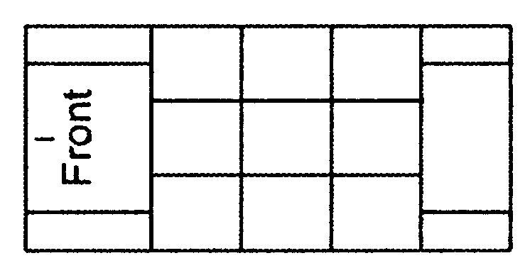  1 Deployed – front  2 Deployed – side  3 Deployed – both front/side  4 Not deployed  5 Not applicable/  No airbag available  6 Unknown |  |  |  |  |  |  |  |  |  |  |  |  |  |  |  |  |  |  |  |  |  | RESTRAINT USE  For each person in your vehicle, enter a Restraint Use code for their seating position.  1 None used – vehicle occupant  2 Lap & shoulder belt used  3 Shoulder belt only used  4 Lap belt only used  5 Child safety seat used  6 Child booster seat used  7 DOT approved helmet used  8 Costume helmet used  9 Restraint use unknown
VEH  NO. |  | N | S |  | E |  |  | W | ROAD OR  HIGHWAY NAME |  |  |  |  |  |  |  |  |  |  | (Enter numbers for each vehicle)
1 |  |  |  |  |  |  |  |  |  |  |  |  |  |  |  |  |  |  |  | YOUR VEHICLE NO. 1 |  |  |  |  |  |  |  |  |  |  |  |  |  |  |  | OTHER VEHICLE NO. 2
2
Vehicle  1 2  01 Essentially straight ahead  02 Backing  03 Changing lanes  04 Overtaking/Passing  05 Turning right  06 Turning left  07 Making U-turn  08 Entering traffic lane  09 Leaving traffic lane  10 Parked  11 Slowing or stopped in traffic  12 Other  13 Unknown |  |  |  |  |  |  |  |  |  |  |  |  |  |  |  |  |  |  |  | POINT OF  IMPACT |  |  |  |  |  |  |  |  |  |  |  |  |  |  |  | POINT OF  IMPACT
 |  |  |  |  |  |  |  |  |  |  |  |  |  |  |  |  |  |  |  | MOST  DAMAGED AREA |  |  |  |  |  |  |  |  |  |  |  |  |  |  |  | MOST  DAMAGED AREA
 |  |  |  |  |  |  |  |  |  |  |  |  |  |  |  |  |  |  |  | 00 None  09 Top & windows  10 Undercarriage  11 Total (all areas)  12 Other |  |  |  |  |  |  |  |  |  |  |  |  | 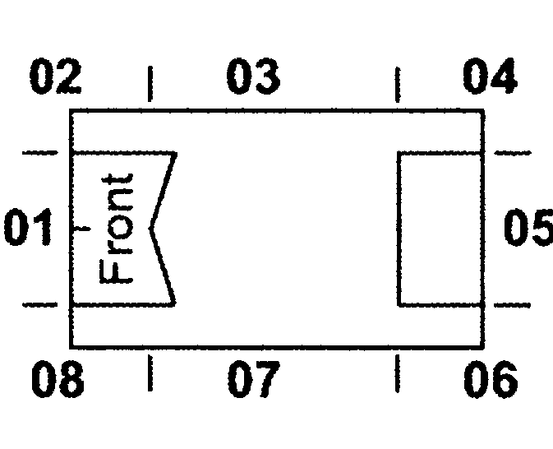
DISPOSITION OF VEHICLE
(Check one for each vehicle)

Vehicle
1 2
1 Towed – due to damages
2 Towed – other reasons
3 Left at scene
4 Driven away
5 Unknown
Total number of
persons in your vehicle
Complete this section for all injured persons in your vehicle, also any bicyclists, pedestrians or fatalities involved in the accident.
Enter the code number which best answers questions 1-5 in the appropriate box located at the lower right.
1. Seating Position  10. Other enclosed  passenger/cargo area  11. Other unenclosed  passenger/cargo area  12. Riding on vehicle exterior  13. Sleeper section of truck cab  14. Trailing unit  15. Moped  16. Motorcycle operator  17. Motorcycle passenger  18. Pedestrian  19. Bicycle (pedalcycle)  20. Unknown |  |  |  |  |  |  |  |  |  |  |  |  |  |  |  |  | (Enter one)  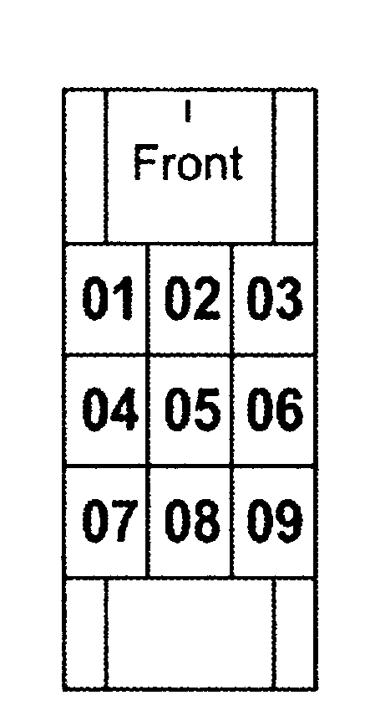 |  |  |  |  |  |  |  |  |  |  |  | 2. Ejected/Trapped  (Enter one)  1. Not ejected or trapped  2. Partially ejected  3. Totally ejected  4. Trapped –  Occupant removed without  use of equipment  5. Trapped –  Equipment used in  extrication  6. Unknown |  |  |  |  |  |  |  |  |  |  |  |  |  |  |  |  |  |  |  |  |  |  |  |  |  |  | 3. Body Region with  Most Severe Injury  (Enter one)  01. Head  02. Face  03. Neck  04. Chest  05. Back/spine  06. Shoulder/upper arm  07. Elbow/lower arm/hand  08. Abdomen/pelvis  09. Hip/upper leg  10. Knee/lower leg/foot  11. Entire body  12. Unknown  13. None |  |  |  |  |  |  |  |  |  |  |  |  |  |  |  |  |  |  |  | 4. Injury Severity  (Enter one)  1. Killed  2. Disabling – cannot leave  scene without assistance  (broken bones, severe cuts,  prolonged unconsciousness,  etc.)  3. Visible but not disabling  (minor cuts, swelling, etc.)  4. Possible but not visible  (complaint of pain, etc.)  5. None |  |  |  |  |  |  |  |  |  |  |  |  |  |  |  |  |  |  |  | 5. Transported to  Medical Facility  (Enter One)  If the individual was transported from the crash site to a medical facility for treatment of injuries received in the crash:  Source of Transport:  1. Not transported  2. EMS (Ambulance)  3. Police  4. Other  5. Unknown
 |  |  |  |  |  |  |  |  |  |  |  |  |  |  |  |  |  |  |  |  |  |  |  |  |  |  |  |  |  |  |  |  |  |  |  |  |  |  |  |  |  |  |  |  |  |  |  |  |  |  |  |  |  |  |  |  |  |  |  |  |  |  |  |  |  |  |  |  |  |  |  |  |  |  |  | DATE OF BIRTH  (MM / DD / YYYY) |  |  |  |  |  |  |  |  |  |  |  |  |  | 1 |  |  |  |  | 2 |  |  | 3 |  |  |  | 4 |  |  |  |  | 5 |  |  | SEX  M F
 |  |  |  |  |  |  |  |  |  |  |  |  |  |  |  |  |  |  |  |  |  |  |  |  |  |  |  |  |  |  |  |  |  |  |  |  |  |  |  |  |  |  |  |  |  |  |  |  |  |  |  |  |  |  |  |  |  |  |  |  |  |  |  |  |  |  |  |  |  |  |  |  |  |  |  |  |  |  |  |  |  |  |  |  |  |  |  |  |  | Seat  Position |  |  |  |  | Eject |  |  | Body Region |  |  |  | Injury  Sev. |  |  |  |  | Trans. |  |  | SEX  M F
NAME ADDRESS |  |  |  |  |  |  |  |  |  |  |  |  |  |  |  |  |  |  |  |  |  |  |  |  |  |  |  |  |  |  |  |  |  |  |  |  |  |  |  |  |  |  |  |  |  |  |  |  |  |  |  |  |  |  |  |  |  |  |  |  |  |  | / /
NAME ADDRESS |  |  |  |  |  |  |  |  |  |  |  |  |  |  |  |  |  |  |  |  |  |  |  |  |  |  |  |  |  |  |  |  |  |  |  |  |  |  |  |  |  |  |  |  |  |  |  |  |  |  |  |  |  |  |  |  |  |  |  |  |  |  | / /
NAME ADDRESS |  |  |  |  |  |  |  |  |  |  |  |  |  |  |  |  |  |  |  |  |  |  |  |  |  |  |  |  |  |  |  |  |  |  |  |  |  |  |  |  |  |  |  |  |  |  |  |  |  |  |  |  |  |  |  |  |  |  |  |  |  |  | / /
NAME ADDRESS |  |  |  |  |  |  |  |  |  |  |  |  |  |  |  |  |  |  |  |  |  |  |  |  |  |  |  |  |  |  |  |  |  |  |  |  |  |  |  |  |  |  |  |  |  |  |  |  |  |  |  |  |  |  |  |  |  |  |  |  |  |  | / /
DR Form 41, January 2011 Return all three completed pages to the address above. Page 1
Driver Contributing Circumstances M  (Check one per driver)  Vehicle  1 2  01 No improper driving  02 Failed to yield right of way  03 Disregarded traffic signs, signals, road markings  04 Exceeded authorized speed limit  05 Driving too fast for conditions  06 Made improper turn  07 Wrong side or wrong way  08 Followed too closely  09 Failure to keep in proper lane or running off road  10 Operating vehicle in erratic, reckless, careless,  negligent, or aggressive manner  11 Swerving or avoiding due to wind, slippery surface,  vehicle, object, non-motorist in roadway, etc.  12 Over-correcting/over-steering  13 Visibility obstructed  14 Inattention  15 Mobile phone distraction  16 Distracted – other  17 Fatigued/asleep  18 Operating defective equipment  19 Other improper action  20 Unknown |  |  |  | Driver Condition (Check one per driver) P  Vehicle  1 2  1 Apparently normal  2 Physical impairment  3 Emotional (depressed, angry, disturbed, etc.)  4 Illness  5 Fell asleep, fainted, fatigued, etc.  6 Under the influence of medications/drugs/alcohol  7 Other (specify)  8 Unknown |  | Road Character D  (Check one)  1 Straight and level  2 Straight and on slope  3 Straight and on hilltop  4 Curved and level  5 Curved and on slope  6 Curved and on hilltop |  | Road E  Surface  (Check one)  1 Concrete  2 Asphalt  3 Brick  4 Gravel  5 Dirt  6 Other (specify) |  |  | Road Surface F  Condition (Check one)  1 Dry  2 Wet  3 Snow  4 Ice  5 Sand, mud, dirt, oil, gravel  6 Water (standing, moving)  7 Slush  8 Other (specify)  9 Unknown
 |  |  |  |  |  | Environment I  Contributing Circumstances  (Check one)  1 None  2 Weather conditions  3 Vision obstruction  4 Glare  5 Animal in roadway  6 Other (specify)  7 Unknown |  | Total G  Number  of Through  Lanes  (Check one)  1 One lane  2 Two lanes  3 Three lanes  4 Four lanes  5 Five lanes  6 Six or more lanes
 |  |  |  | Road Contributing Circumstances J  (Check one per driver)  Vehicle  1 2  01 None  02 Road surface condition (wet, icy, snow, slush, etc.)  03 Debris  04 Rut, holes, bumps  05 Work zone (construction/maintenance/utility)  06 Worn, travel-polished surface  07 Obstruction in roadway  08 Traffic control device inoperative, missing or obscured  09 Shoulders (none, low, soft, high)  10 Non-highway work  11 Other (specify)  12 Unknown |  |  |  |  |  |  | Median Type H  (Check one)  1 Median barrier  2 Raised median (curbed)  3 Grass median (no curb)  4 Painted (no curb)  5 None
 |  |  |  |  |  | Light Condition C  (Check one)  1 Daylight  2 Dawn  3 Dusk  4 Dark-lighted roadway  5 Dark-roadway not lighted  6 Dark-unknown roadway  lighting  7 Other (specify)  8 Unknown |  | Weather Condition (Check up to two) A1 & 2  01 None 06 Snow  02 Cloudy 07 Severe crosswinds  03 Fog, smog, smoke 08 Blowing sand, soil,  04 Rain dirt, snow  05 Sleet, hail, freezing 09 Other (specify)  rain/drizzle 10 Unknown
Was the crash in or near a construction R
maintenance or utility work zone?
(Check one)
1 No 2 Unknown 3 Yes

INDICATE BY DIAGRAM WHAT HAPPENED
Indicate North
by Arrow
DESCRIBE WHAT HAPPENED (Refer to your vehicle as No. 1, any others as No. 2, No. 3, etc.)
PROPERTY | NON-VEHICLE OBJECT DAMAGED |  | OWNER NAME |  | ADDRESS |  | PHONE  ( ) - |  |  | APPROX. COST OF DAMAGE  $
PROPERTY | NON-VEHICLE OBJECT DAMAGED |  | OWNER NAME |  | ADDRESS |  | PHONE  ( ) - |  |  | APPROX. COST OF DAMAGE  $
Was a Police  Officer Contacted? |  | Yes  No | OFFICER NAME OR BADGE NUMBER |  |  | DEPARTMENT (Name of City, County, etc.)
I certify, to the best of my knowledge, that this report is true and accurate.   |  |  | OPERATOR SIGNATURE (Required if physically able) |  |  |  |  |  | DATE
Return all three completed pages of Accident Report to address located on top of Page 1.

ON-LINE VERSION | DRIVER MUST COMPLETE IN FULL
You, the driver, must provide information about the liability insurance covering the motor vehicle you were driving. Please complete the following.
Name of Insurance Company Affording
Liability Coverage on Date of Accident
Address
Vehicle Information: |  |  |  | VIN No. |  |  |  |  |  |  |  | Year |  |  |  | Make |  |  | Model
Name of Agent  Who Sold Policy |  |  |  |  |  |  |  |  |  |  | Address
Policy No. |  |  |  |  |  |  |  | Date of Accident |  |  |  |  |  | in or near |  |  |  |  |  |  | , Nebraska
 |  |  |  |  |  |  |  |  |  | (Month, Day, Year)
Driver |  |  |  |  |  |  |  |  | Address
Owner |  |  |  |  |  |  |  |  | Address
Name of Policyholder

ON-LINE VERSION | THIS SIDE FOR INSURANCE COMPANY USE ONLY
TO: Department of Motor Vehicles
Financial Responsibility Section Please return this form immediately if policy
301 Centennial Mall South was not in effect as described by motorist.
PO Box 94789
LINCOLN NE 68509-4789 Do not return form if policy was in effect.
The undersigned company advises that the insurance policy, as described on the reverse side, does not afford liability coverage to both the driver and owner in the limits of $25,000 – $50,000 bodily injury and $25,000 property damage for this accident because of the following reasons:

(please complete)
Name of Insurance Company |  | Authorized Representative |  | Date

INSURANCE INFORMATION
Please read instructions carefully.
Return this entire page with the completed Accident Report.

